CS 3310

Project 1

Charlson So

Task 1: Sorting Algorithms

For task 1, a merge sort and a quick sort was done over a n space.

|  |  |  |  |  |
| --- | --- | --- | --- | --- |
| Merge Sort |  |  | Quick Sort |  |
|  |  |  |  |  |
| n | time (s) |  | n | time (s) |
| 1000 | 0.004224 |  | 1000 | 0.001679 |
| 10000 | 0.048206 |  | 10000 | 0.022199 |
| 100000 | 0.557471 |  | 100000 | 0.285717 |
| 1000000 | 6.450567 |  | 1000000 | 3.942764 |
| 10000000 | 81.781673 |  | 10000000 | 48.711425 |
| 20000000 | 168.26144 |  | 20000000 | 98.039804 |
| 30000000 | 268.907934 |  | 30000000 | 154.410671 |
| 40000000 | 359.201466 |  | 40000000 | 319.966751 |
| 100000000 | 611.411217 |  | 100000000 | 969.651313 |

Quick Sort and Merge Sort have similar average time complexities [O(n * log(n))] The values in the array were computed with random values and we can assume that the values would be similar to that of an average case.

Task 2: Tower of Hanoi

Tower of Hanoi: Time taken to compute size n

|  |  |
| --- | --- |
|  | |
|  |  |
| n | time (s) |
| 2 | 5.00E-06 |
| 4 | 1.00E-05 |
| 8 | 5.50E-05 |
| 16 | 0.011409 |
| 17 | 0.021422 |
| 20 | 0.14517 |
| 24 | 2.343597 |
| 25 | 4.459937 |
| 26 | 9.121861 |
| 27 | 19.038829 |
| 28 | 37.606982 |
| 29 | 73.424612 |
| 30 | 151.433385 |
| 31 | 288.679369 |
| 32 | 607.792373 |

Tower of Hanoi’s time complexity is O(2^n). This can be proved by the recurrence relation below. The graph seems to show a 2^n time complexity.

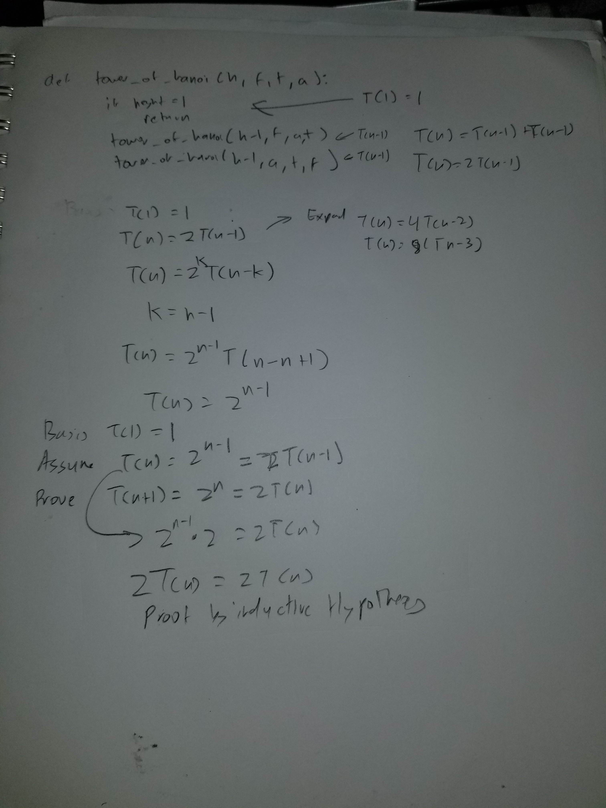

For Tower of Hanoi, I removed the debugging statements since it took so long.

Task 3: Matrix Multiplication

|  |  |  |  |  |
| --- | --- | --- | --- | --- |
| Classical Matrix Multiplication | | | Strassen Matrix Multiplication | |
|  |  |  |  |  |
| n | time (s) |  | n | time (s) |
| 2 | 1.60E-05 |  | 2 | 1.80E-05 |
| 4 | 3.40E-05 |  | 4 | 3.00E-05 |
| 8 | 0.000204 |  | 8 | 0.000203 |
| 16 | 0.001429 |  | 16 | 0.001338 |
| 32 | 0.005721 |  | 32 | 0.005968 |
| 64 | 0.040312 |  | 64 | 0.038895 |
| 128 | 0.305997 |  | 128 | 0.307993 |
| 256 | 2.547319 |  | 256 | 2.494767 |
| 512 | 20.767864 |  |  |  |
| 1024 | 193.420958 |  |  |  |

Strassen Matrix Multiplication is more efficient than classical when the n size is large. This is because the time complexity for Strassen is O(n^3 – n^2) and Classical is O(n^3).